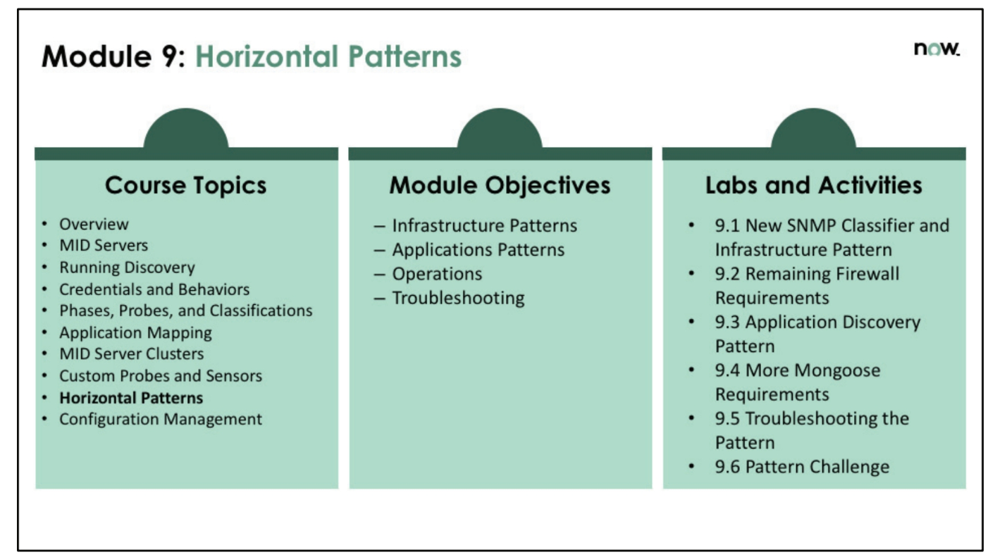

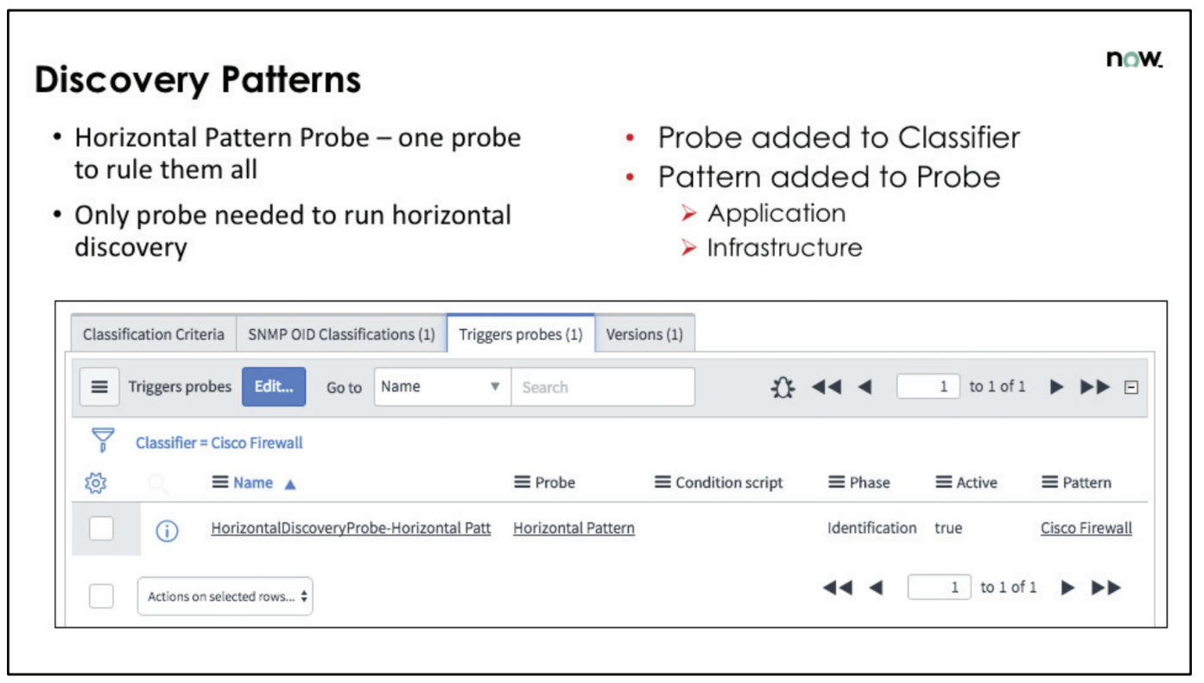

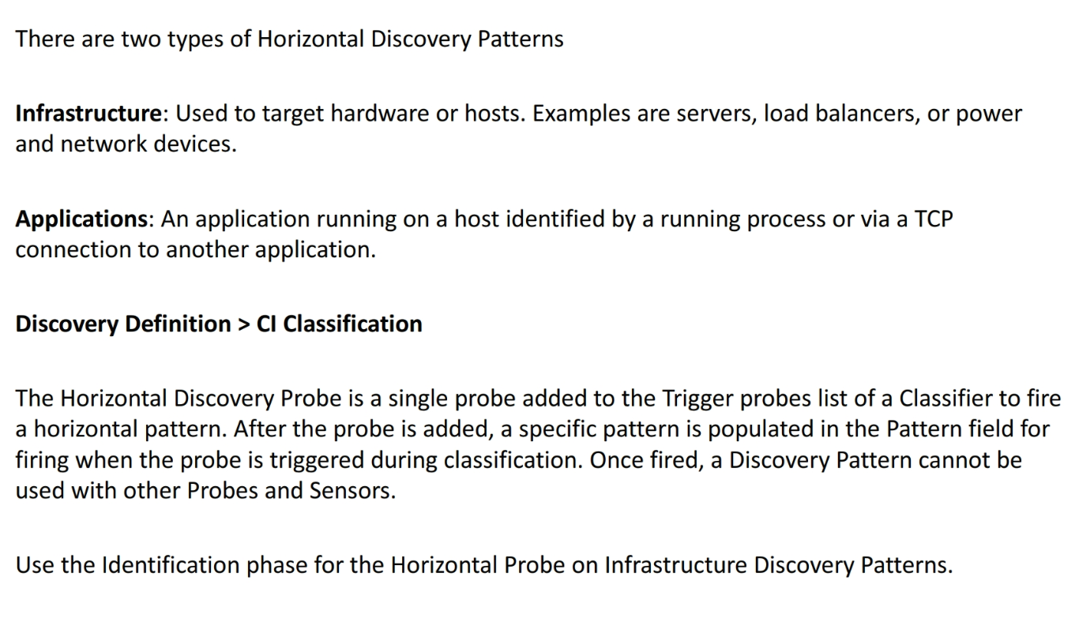

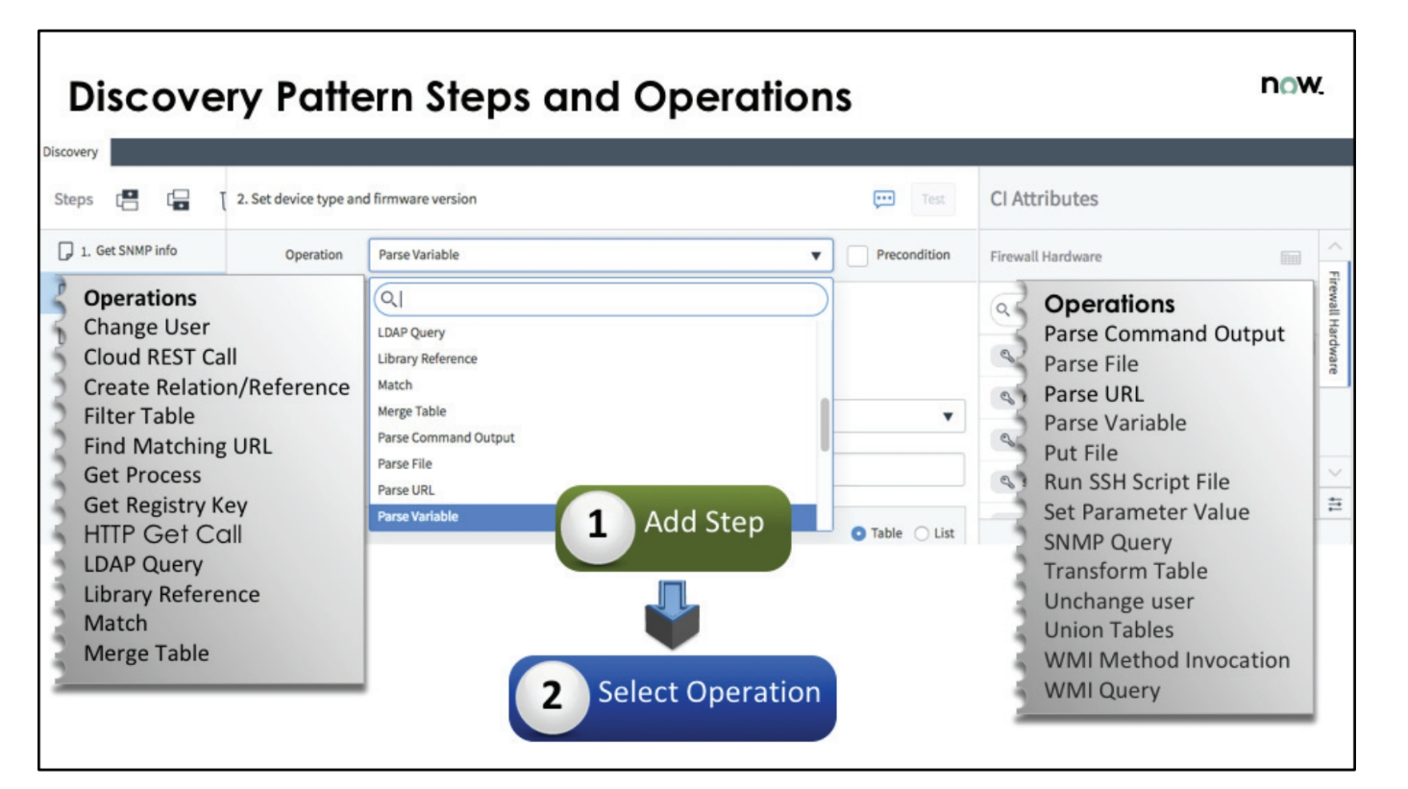

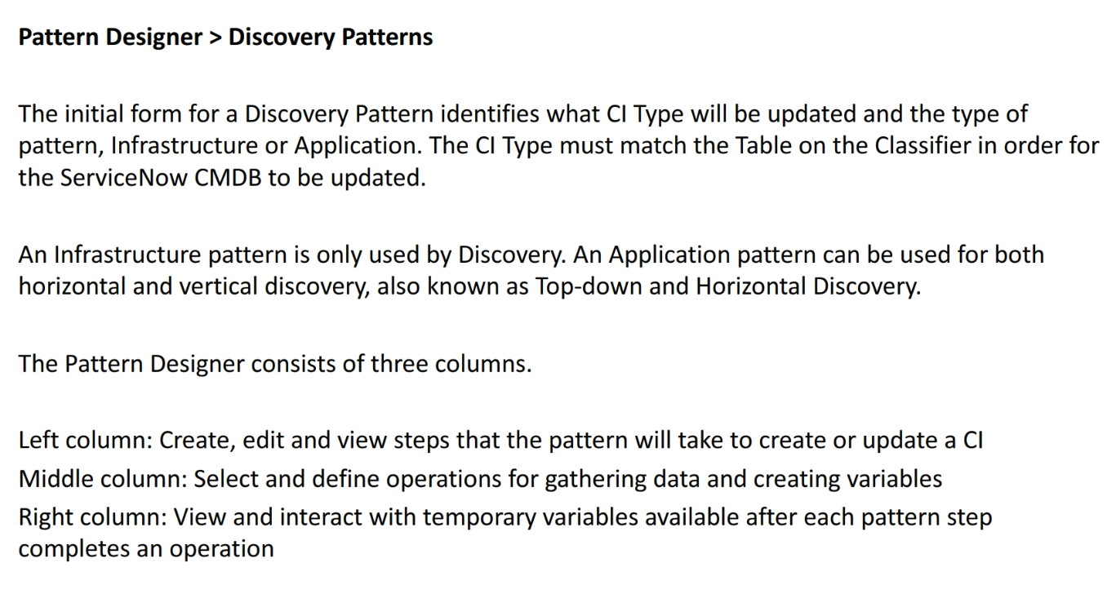

Steps -----------------------------Operations -------------------------------variables----------------------------

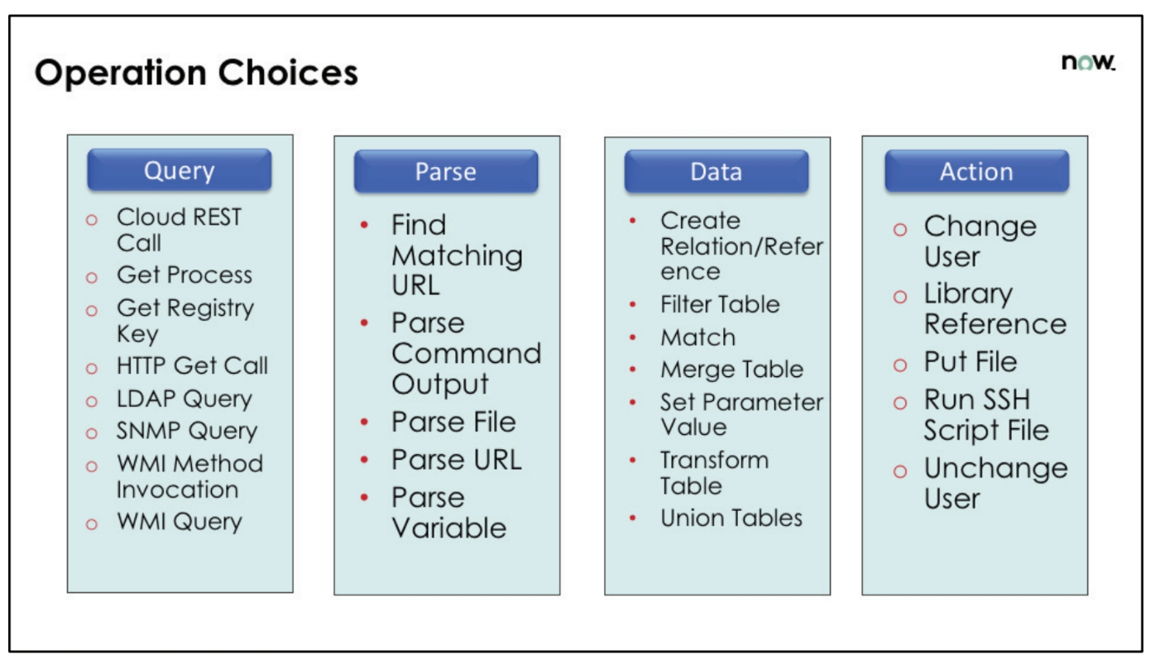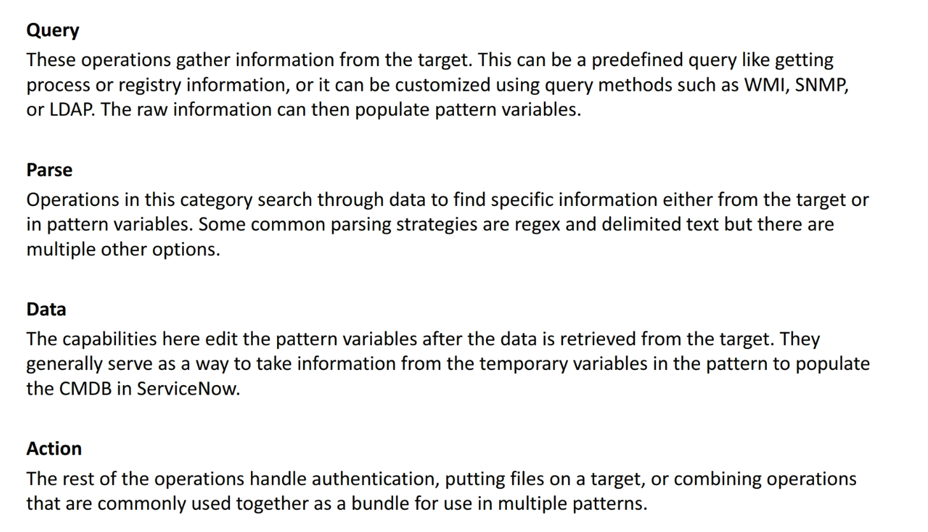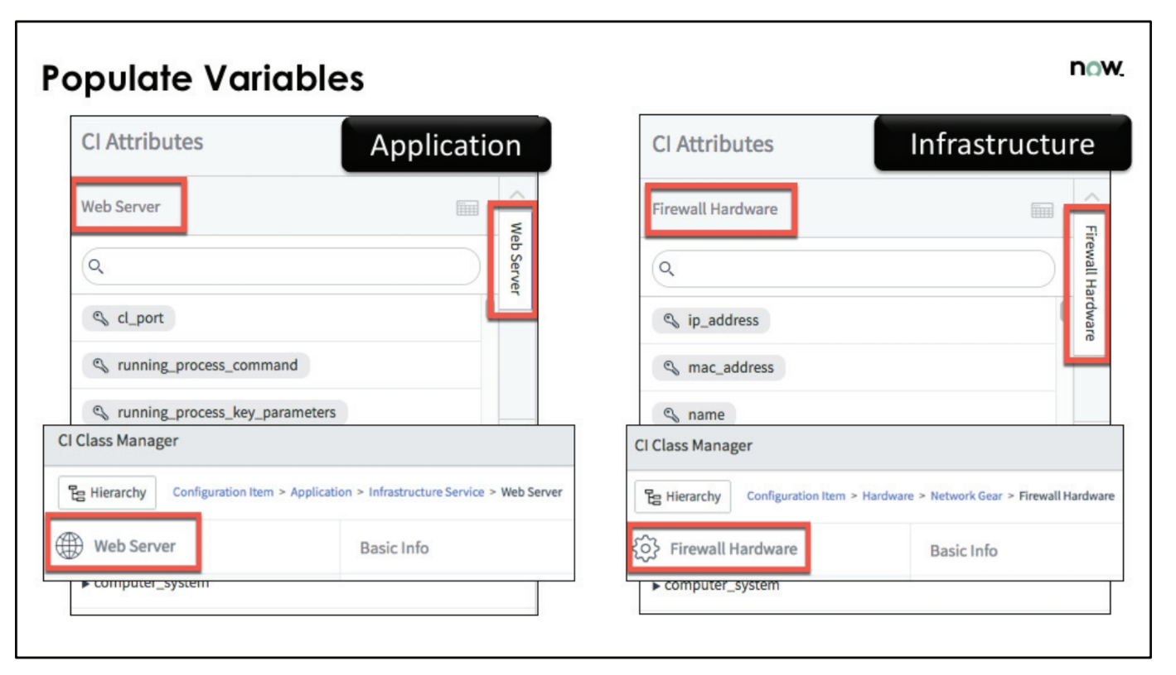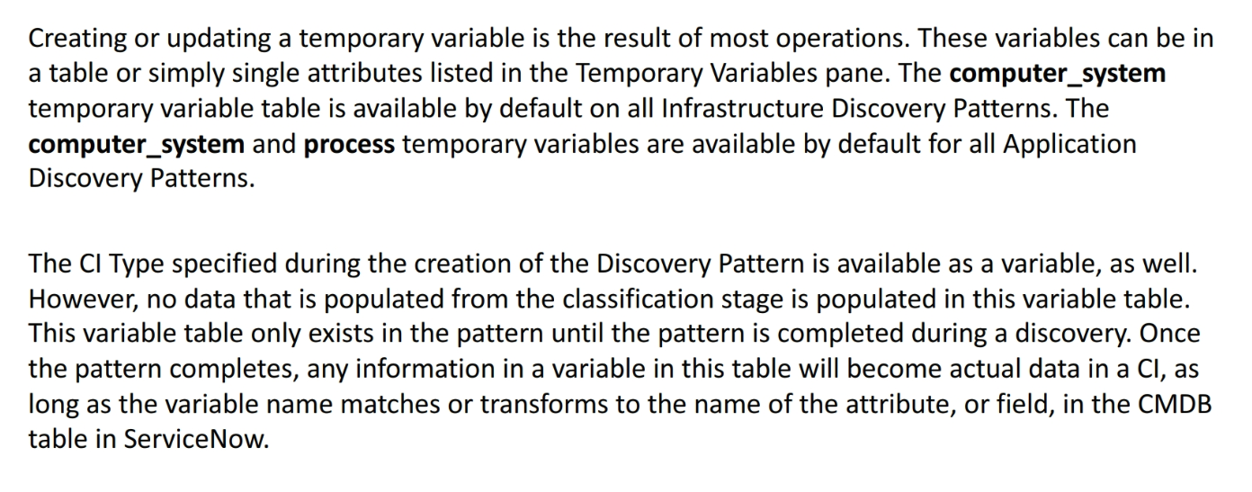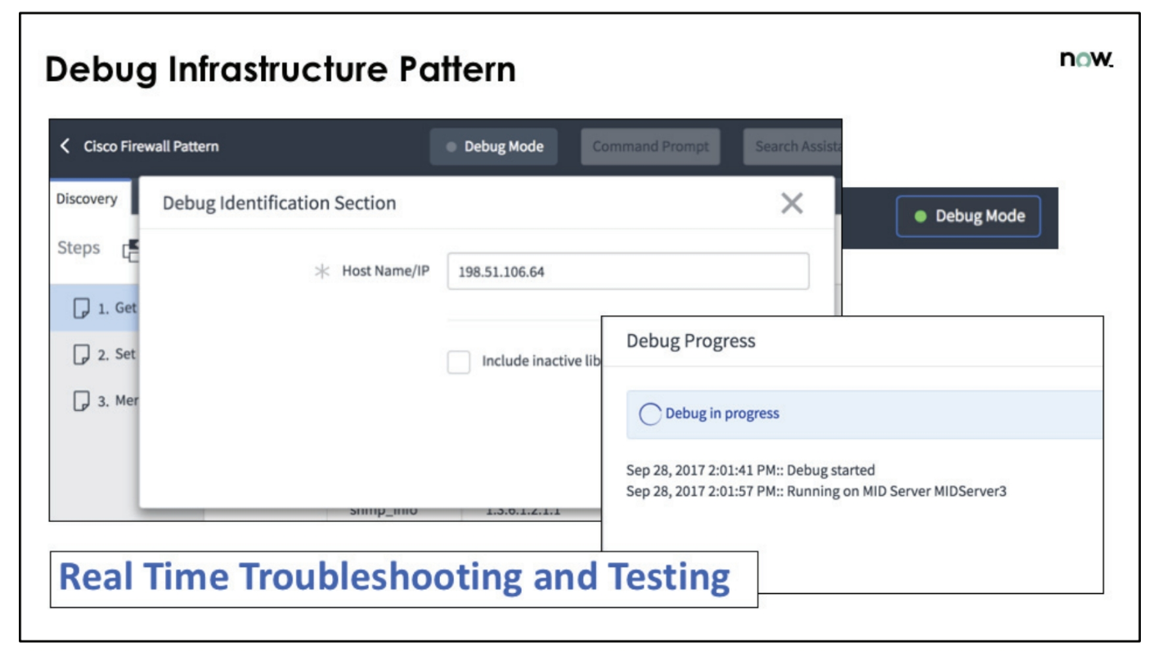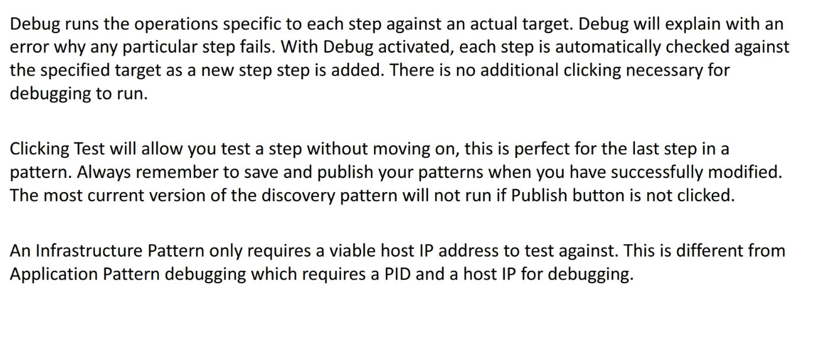

=================================================================================

Basic **||** Pattern **||** Input parameters

=================================================================================

Pattern Type (Infrastructure | Application 🡪) Operating system

Name Run Order (None, before, after)

Description Enforce Process Classification

**CI Type (cmdb_ci_firwall_network)**

Active

==================================================================================

Identification Section

==================================================================================

Extension section

==================================================================================

Connection Section

Discovery Definition > CI classification > SNMP >Triggers Probe >

> Horizontal Pattern

> Phase > Identification

> Pattern Name

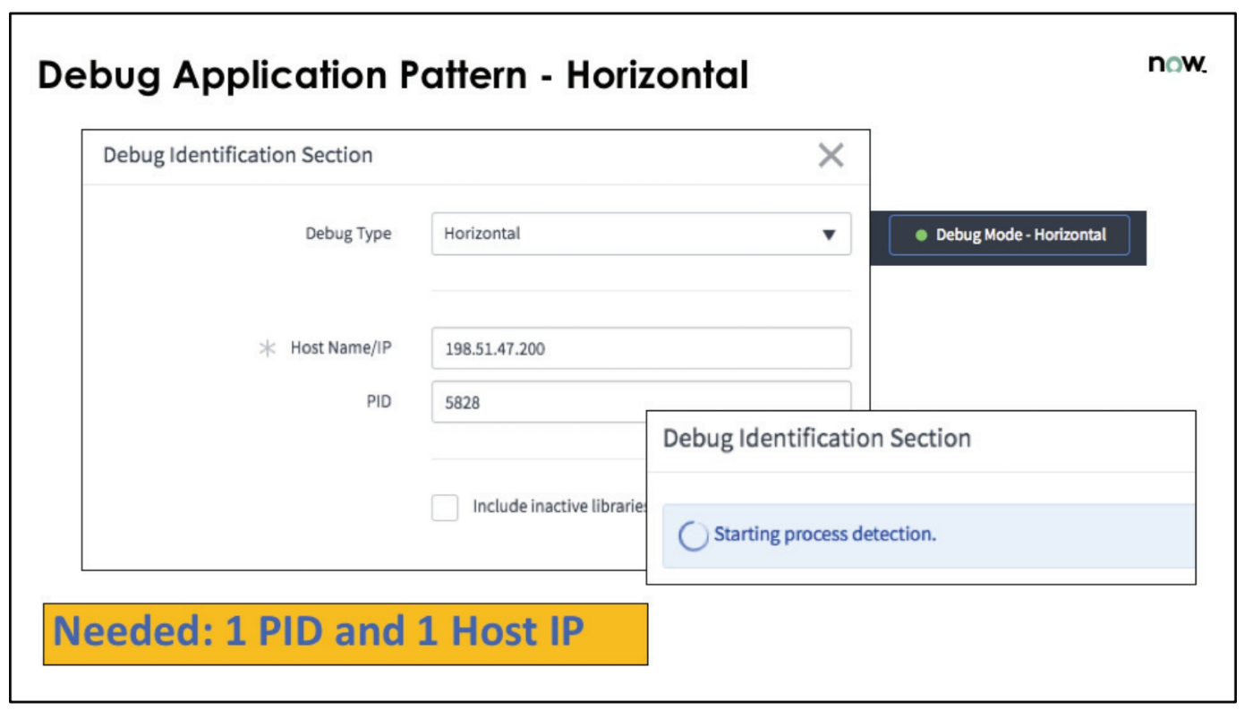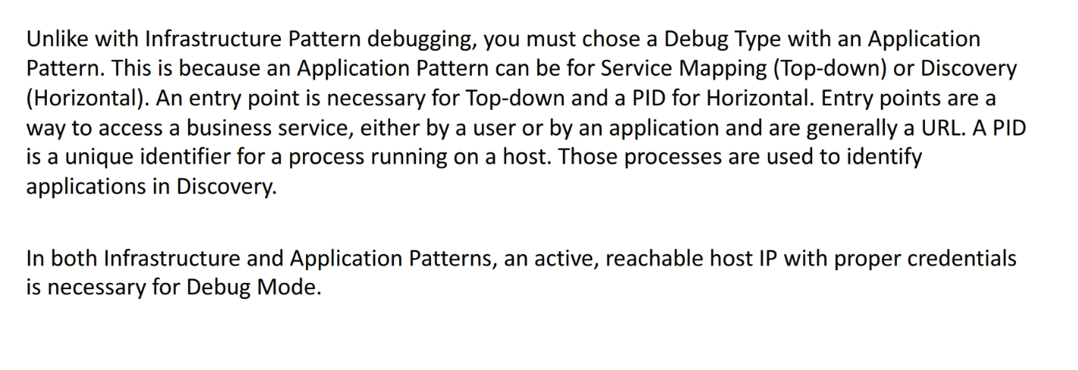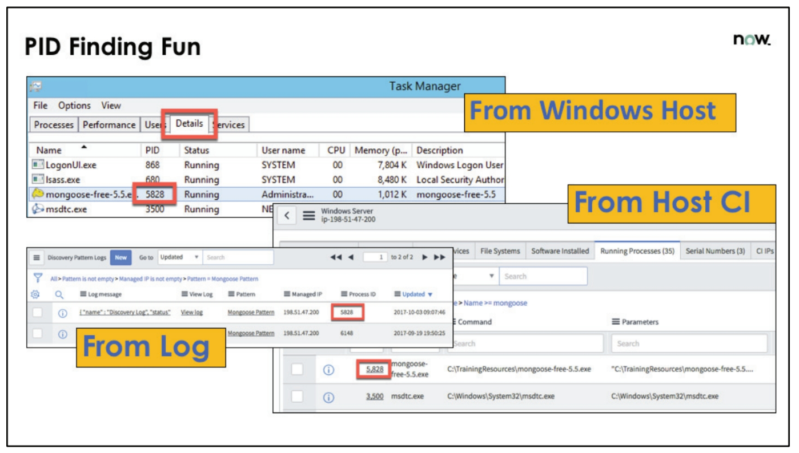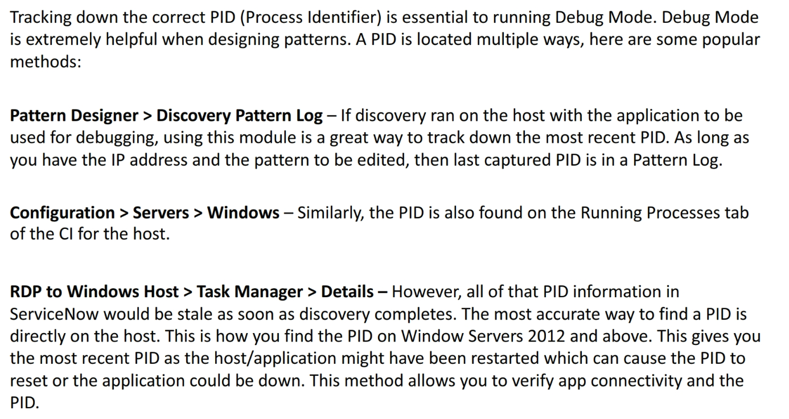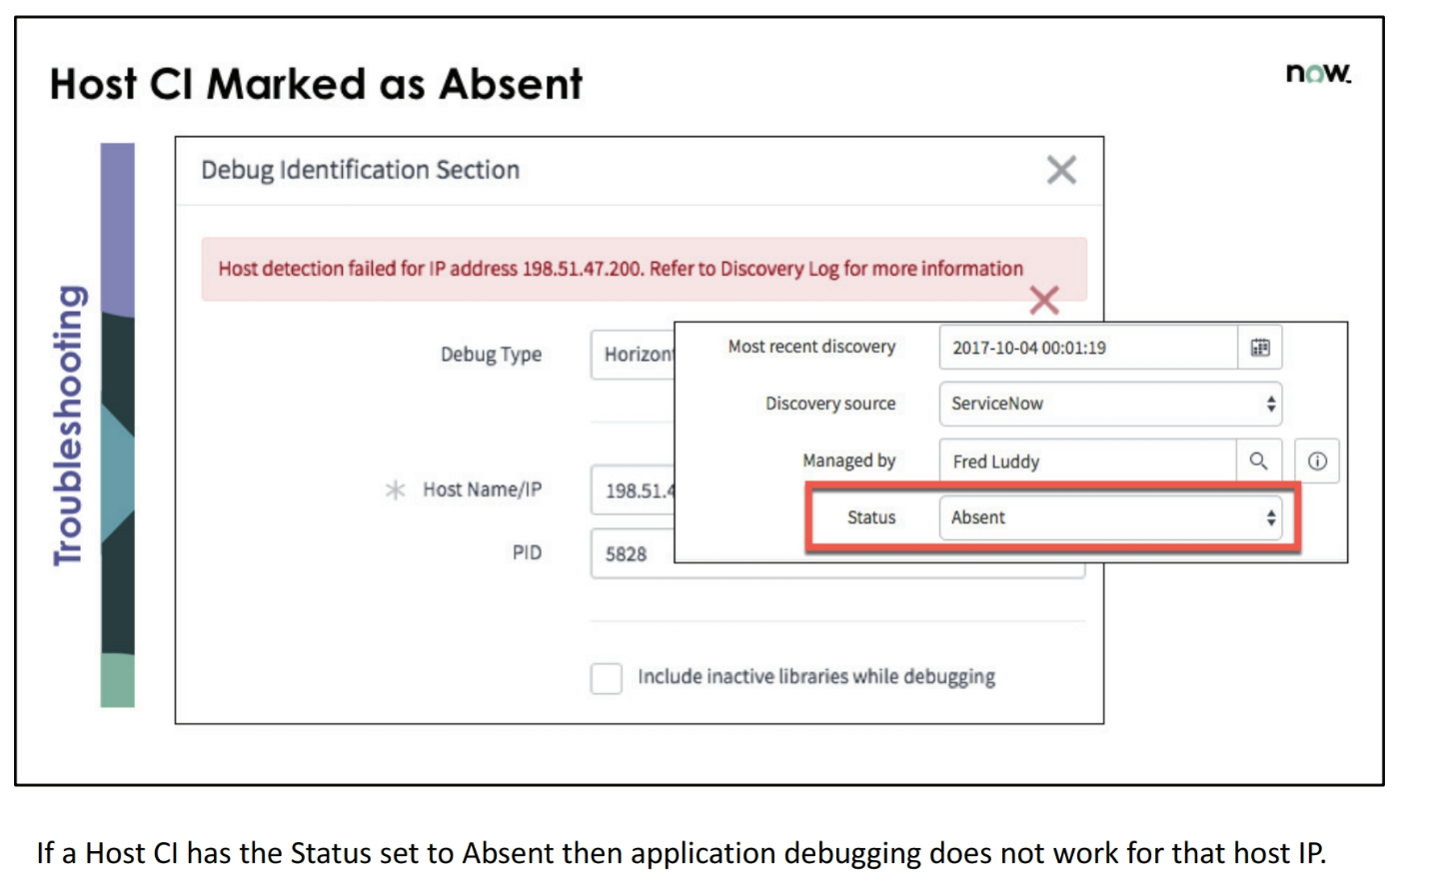

Enter values and variables in patterns

|  |  |  |
| --- | --- | --- |
| Enter constant values, a string | Enclose the value in quote marks ("). |  |
| Enter a value that can change, a variable | Start the variable name with the dollar sign ($). |  |
| Enter a value that can change from a variable that contains several variables | Enter the variable name in the following format:  $<container_variable>.<variable> |  |
| Enter a value from the specific field in a table | Enter the variable in the following format:  $tabular_variable[row number].column_name |  |
| Enter values from a specific column in a table sequentially, starting from the current row | Enter the variable in this format:  $tabular_variable[].column_name |  |
| Enter values from a specific column in a table sequentially, starting from the first row | Enter the variable in this format:  $tabular_variable[*].column_name |  |
| Use the eval() function to evaluate a string in the field | 1. Type EVAL( and click the edit button Edit button next to the field. 2. In the EVAL Script Editor window, ensure that the JavaScript mode is on or click **Other** for other types of scripts like Groovy. 3. Type the script in the editor pane. 4. If necessary, use the **Search**,**Replace**, and **Format** buttons to modify the script. Linting and highlighting is available for JavaScript. 5. Click **Apply**. |  |
|  |  |  |

Pattern Operations:

Parse:

1.Parse Variable: **Parse variable** operation to extract information from a variable and to store it in a variable table.

| **Parsing strategy** | **Description** |
| --- | --- |
| Oracle  LDAP file  XML file  INI file  Properties file  JSON file (custom) | Horizontal file parsing strategy (not vertical). You can use this parsing strategy only for text files. For more information, see [Parse text from a horizontal file](https://docs.servicenow.com/bundle/london-it-operations-management/page/product/service-mapping/task/t_FileTypeParsStratPatDef.html). |
| Vertical File | Retrieve text from a structured text file where each set of data spans multiple lines. For more information, see [Parse text from a vertical file](https://docs.servicenow.com/bundle/london-it-operations-management/page/product/service-mapping/task/t_VerticalFileParsStratPatDef.html). |
| After Keyword | Retrieve text directly following a specific keyword. For more information, see [Parse text using keyword, command, and positional type](https://docs.servicenow.com/bundle/london-it-operations-management/page/product/service-mapping/task/t_KeyCmdPosTypeParsStratPatDef.html). |
| Command Line Java Style | Retrieve the value of a command-line parameter using Java-style parameters. For more information, see [Parse text using keyword, command, and positional type](https://docs.servicenow.com/bundle/london-it-operations-management/page/product/service-mapping/task/t_KeyCmdPosTypeParsStratPatDef.html). |
| Command Line Unix Style | Retrieve the value of a command-line parameter using standard Unix parameters. For more information, see [Parse text using keyword, command, and positional type](https://docs.servicenow.com/bundle/london-it-operations-management/page/product/service-mapping/task/t_KeyCmdPosTypeParsStratPatDef.html). |
| Position From End | Retrieve text specified by its position from the end of the line. For more information, see [Parse text using keyword, command, and positional type](https://docs.servicenow.com/bundle/london-it-operations-management/page/product/service-mapping/task/t_KeyCmdPosTypeParsStratPatDef.html). |
| Position From Start | Retrieve text specified by its position from the beginning of the line. For more information, see [Parse text using keyword, command, and positional type](https://docs.servicenow.com/bundle/london-it-operations-management/page/product/service-mapping/task/t_KeyCmdPosTypeParsStratPatDef.html). |
| Regular Expression | Retrieve text specified by a regular expression. This option requires familiarity with Regex Java syntax. For more information, see [Parse text using a regular expression](https://docs.servicenow.com/bundle/london-it-operations-management/page/product/service-mapping/task/t_RegularExpParsStratPatDef.html). |
| Delimited Text | Retrieve text specified by delimiters and position within the line (the most common way to retrieve text from generic text files). See [Parse text using delimited text](https://docs.servicenow.com/bundle/london-it-operations-management/page/product/service-mapping/task/t_DelimitedTextParsStratPatDef.html). |

2.Parse Command Output: **Parse command output** operation to extract information from the command output and to save the operation result in a variable. You can also save the whole of command output as a variable.

3.Parse file: **Parse file** operation to extract information from a file and create variables to contain the extracted information.

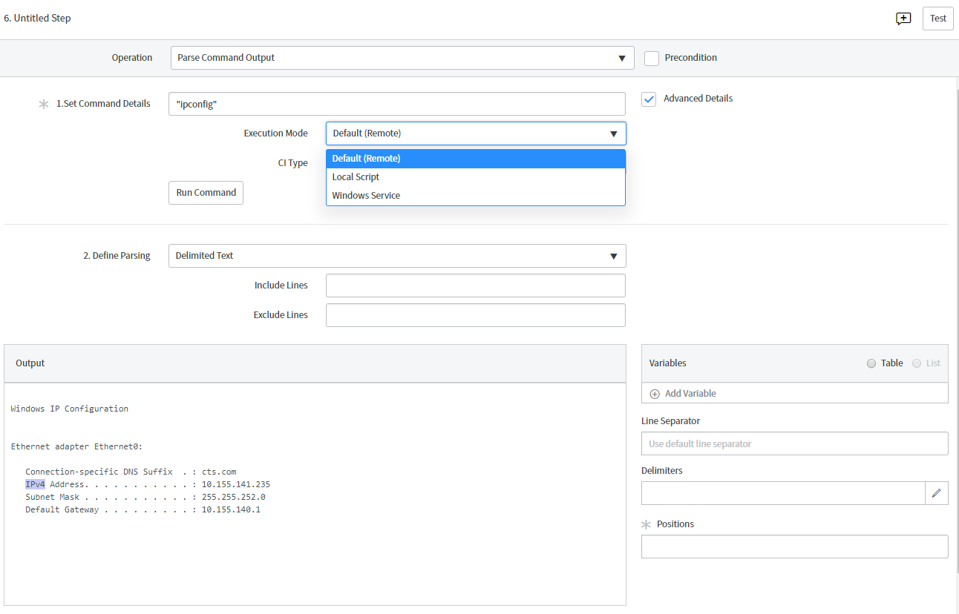

4.Parse url:  **Parse URL** operation to break down a URL to the component level.

5.Find Matching URL: **Find Matching URL** operation to find the best match for the main URL and create a variable to hold it.

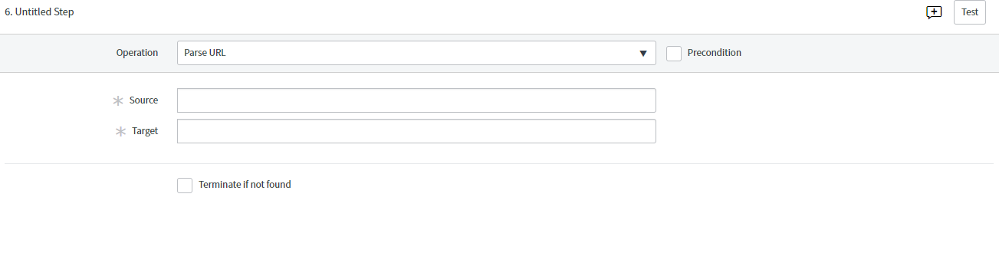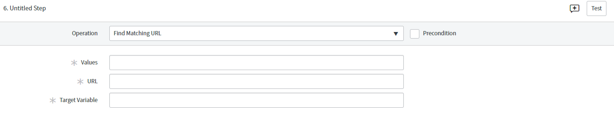

Table:

1.Create Relation and Reference: Relation and/or Reference condition to create relationships and references between CIs a pattern discovers. This operation is relevant for both infrastructure and application patterns that Discovery uses for horizontal discovery.

| **Relation and/or Reference operation fields** | |
| --- | --- |
| **Field** | **Description** |
| Parent Table | Enter the name of the table for the CI that you want to use as a parent CI in the relation. For example,cmdb_ci_lb_pool for the load balancer pool CI. |
| Child Table | Enter the name of the table for the CI that you want to use as a child CI in the relation. For example,cmdb_ci_lb_pool_member for the load balancer pool member, which the load balancer pool owns. |
| Result Table | Enter the name for the new table to store information about relations and references between CIs, resulting from this operation. |
| Relation Type | Select the type of relationship between CIs from the specified target tables. The part in the type name before the separator (::) refers to the parent CI and the second part, after the separator (::), to the child CI. For example, in the **Owns::Owned by** option:   * "Owns" indicates that a load balancer pool [cmdb_ci_lb_pool] owns a load balancer pool member [cmdb_ci_lb_pool_member]. * "Owned by" indicates that a load balancer pool member [cmdb_ci_lb_pool_member] is owned by a load balancer pool [cmdb_ci_lb_pool].   **Warning:** Make sure to choose the right option among relation types using the same words, like **Used by::Uses** and**Uses::Used by**. |
| Reference | Select this check box to create a reference between the parent and the child CIs. |
| Direction | (Only if **Reference** is selected) Select the direction of the reference:   * **Parent to Child**to display the parent CI on the child CI form. For example, the load balancer pool member form displays load balancer pool, which owns this pool member. * **Child to Parent** to display child CIs on the parent CI form. For example, the load balancer pool form displays load balancer pool members this pool owns. |
| Column Name | (Only if **Reference** is selected) Enter the name of the field in the child CI table that the system uses to create the reference. For example, load_balancer. |
| Creation Criteria | Select the criteria used to create the relation and/or reference:   * **All**   The system creates a relationship or reference without any additional criteria.   * **Field matching**   The system creates the relationship or reference only if the value in the specified field in a parent CI matches the value of the specified field in a child CI.   * **Condition**   The system creates the relationship or reference only if the specified criteria is matched. |
| Parent table field | (Only if **Field matching** is selected) Enter the field from the parent table to compare.  You can use variables including values from tabular variables as described in [Enter values and variables in patterns](https://docs.servicenow.com/bundle/london-it-operations-management/page/product/service-mapping/reference/r_UsefulShortcutsPatDef.html). |
| Child table field | (Only if **Field matching** is selected) Enter the field from the child table to compare. |
| Unmatched values | Operation for values in the two tables that do not match. You can keep or remove unmatched values. |

2.Filter Table: **Filter table** operation to search a source table for a specified value. If found, values are logged in a specified target table.

3.Union Table:

**Union table** operation to append two tables of the same format.

4.Transform Table:

**Transform table** operation to add one or more computed columns to an existing table and place the results in a target table. The target table can be the source table.

5.Merge Table: **Merge Table** operation to merge content from two source tables into a target table.

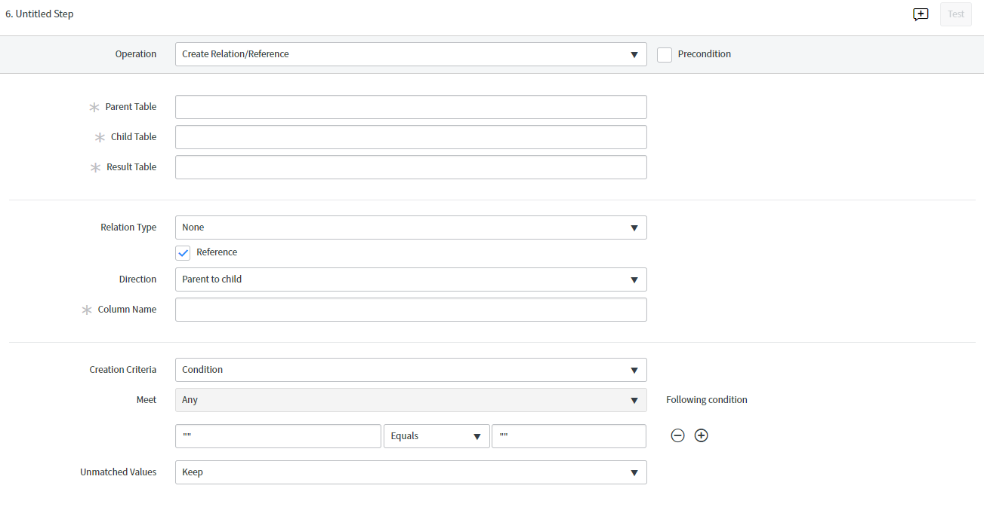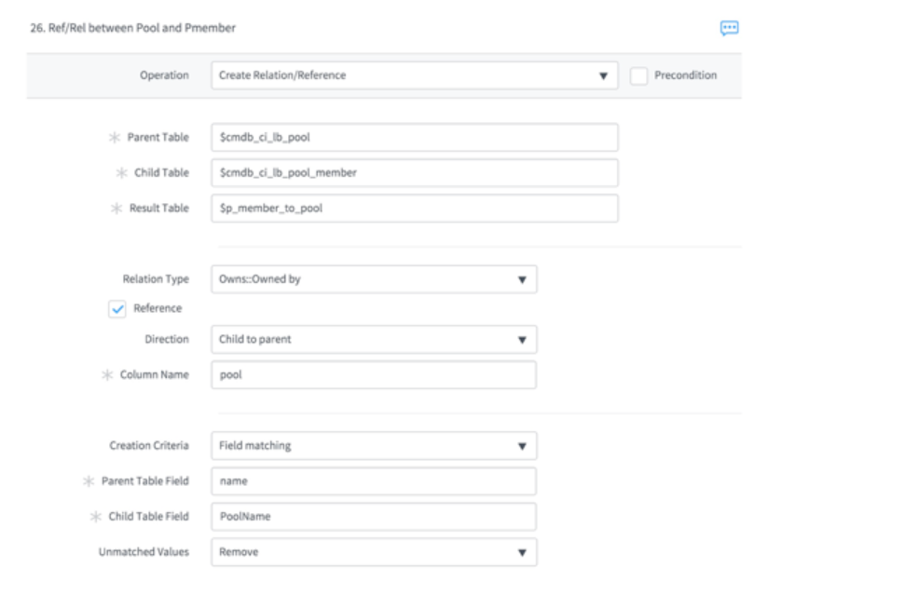

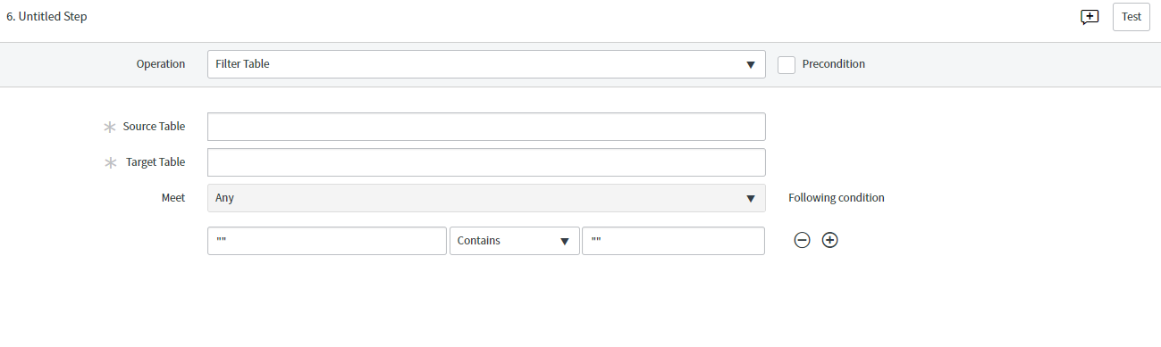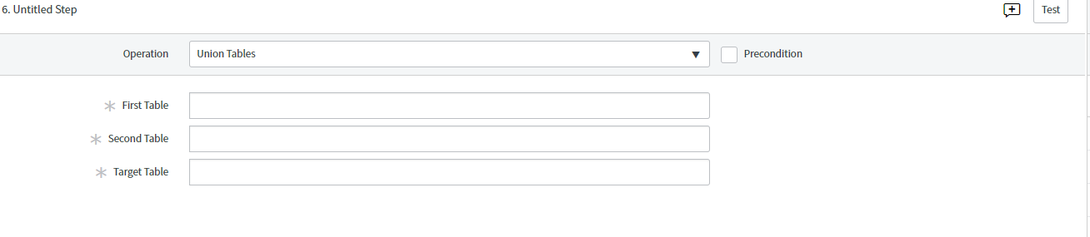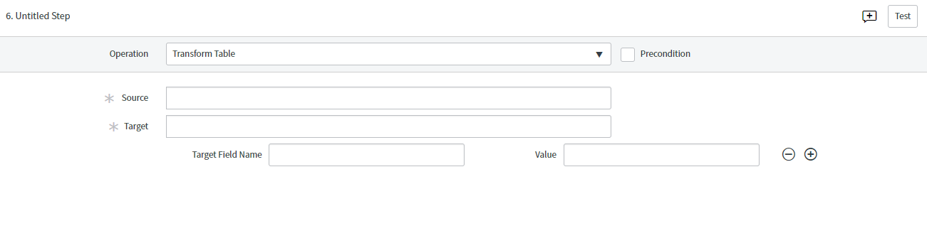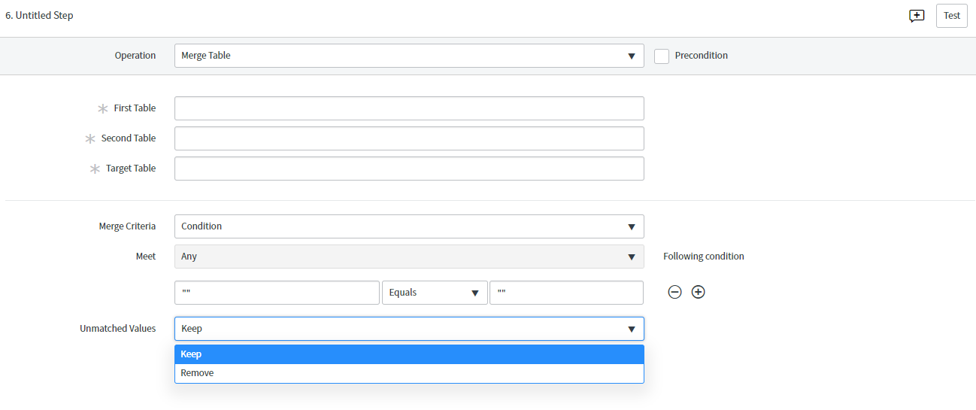

Other:

Set Parameter Value: **Set Parameter Value** operation to apply a value to a parameter.

Change User : Use operating system credentials instead of the default administrative credentials.

As part of creating or modifying a discovery pattern, you can define a **Change user** operation to make Service Mapping or Discovery use SSH or Windows credentials instead of the default administrative level credentials. This operation is relevant only for configuration items (CIs) hosted on Windows or Unix operating systems.

Unchange User : Switch back to the default administrative credentials.

Put file:

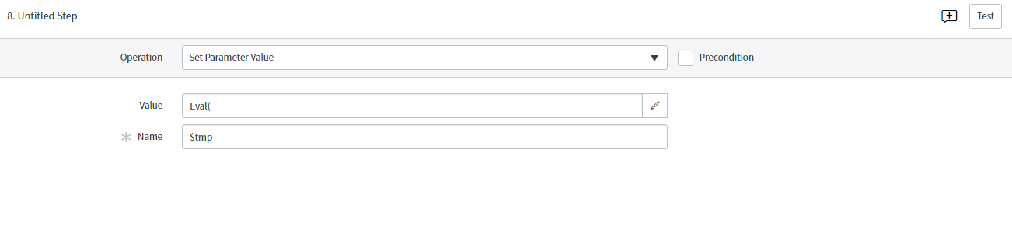

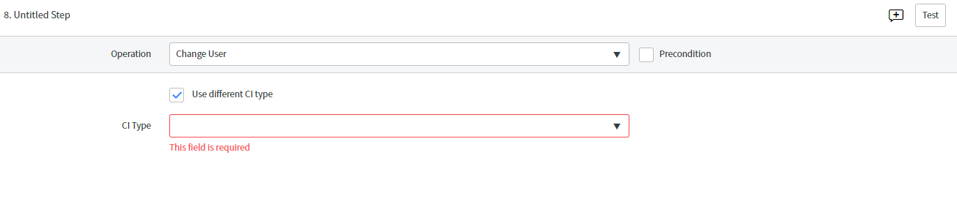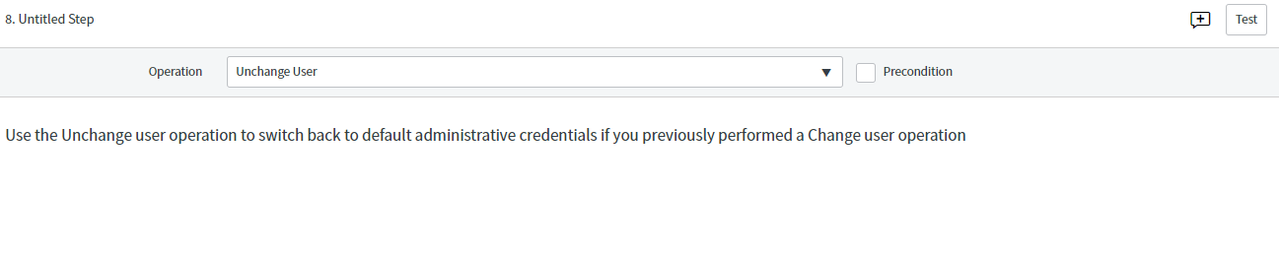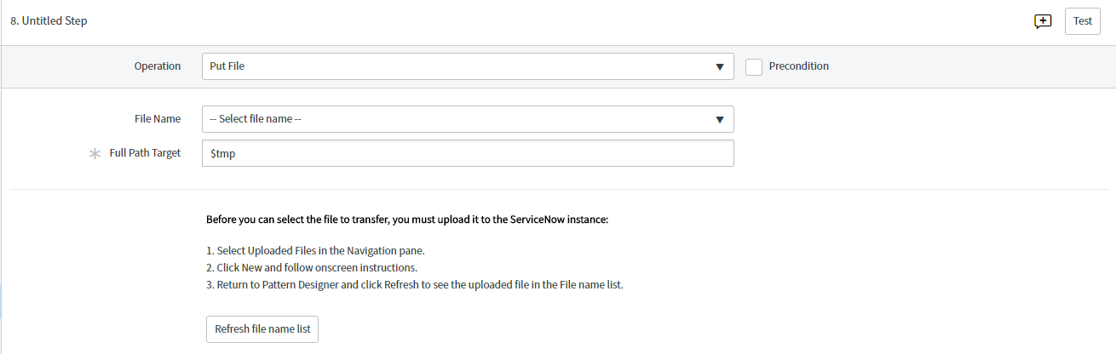

Structure:

Library reference :

you can reuse a sequence of discovery steps that you created for one pattern in other patterns. Saved shared step sequences become pattern modules referred to as shared libraries.

The selected steps are saved as a shared library in the Discovery Patterns [sa_pattern] table.

Match

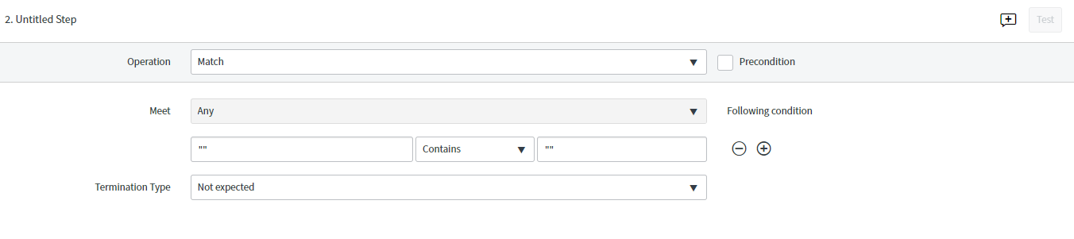

Query:

Get Process :

**Get process** operation to search for a specific process to store in a tabular variable.

| **Field** | **Description** |
| --- | --- |
| **Process ID** | Enter the process ID. Not recommended since this parameter can be modified. |
| **Command Line** | Enter the command line or a string which is part of it. For example, you can use "bw" to find "bwengine." |
| **Working Directory** | Enter the working directory for the process. Not recommended, since this parameter can vary on different hosts. |
| **Parent Process** | Enter the process which is the parent of the process that you want to extract. Not recommended since this parameter can be modified or can extract many irrelevant sub processes. |
| **Port** | Enter the port on which the process runs. Not all processes are based on ports. |

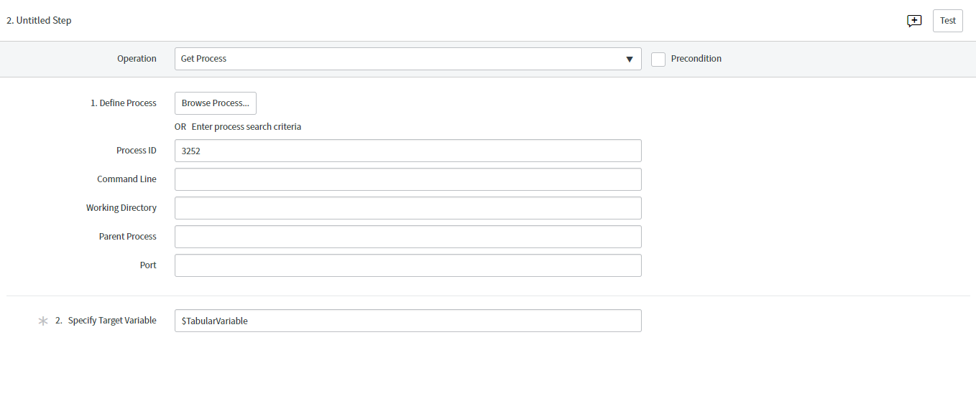

Get Registry Key:

**Get registry key** operation to retrieve and select registry key attributes to store in a table.

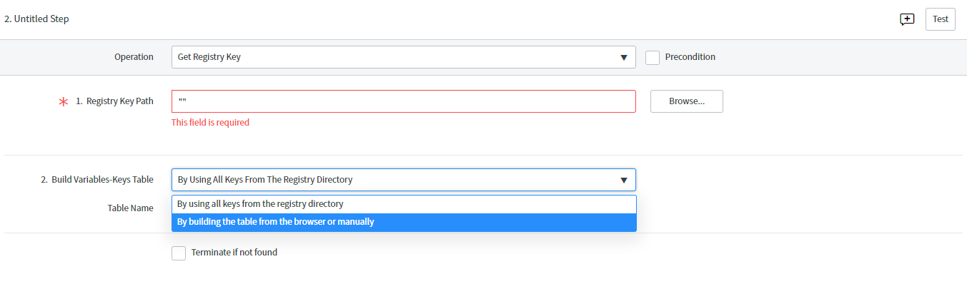

LDAP Query:

1. **LDAP query** operation to query an LDAP directory. Select **LDAP query** from the **Operation** list.
2. Fill in the fields, as appropriate.

| **Field** | **Description** |
| --- | --- |
| Base DN | Specify the point from where the LDAP server searches for users. |
| Host | Specify the name of the server that hosts the LDAP server. |
| Port | Specify the port name. |
| Query | Specify the query parameters. |
| Scope | Specify the query scope from the list:   * + **Sub Tree**: the object and all descendants.   + **Object**: the object only.   + **One Level**: the object and one level below. |

1. In the **Variable Table**, click **Add** and define the table name and column name to hold the query result.

For multiple results, click **Add** for each additional column that is needed.

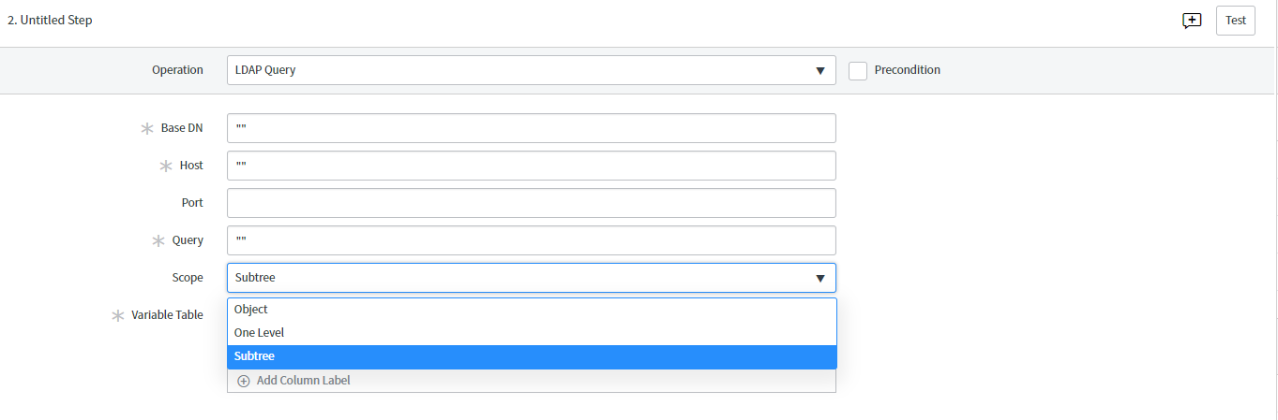

SNMP Query:

**SNMP query** operation to execute SNMP queries on CIs that support the SNMP protocol, typically, load balancers.

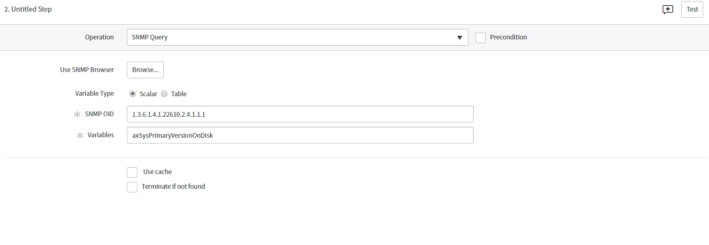

WMI Query:

1. **WMI query** operation to execute a query on a remote Windows system either explicitly or automatically. Successful values are logged in a specified target table. Select **SNMP query** from the **Operation** list.
2. To browse to the SNMP OID that you want to query using the debug mode:
   1. [Activate pattern Debug mode](https://docs.servicenow.com/bundle/london-it-operations-management/page/product/service-mapping/task/t_ActivateDebugMode.html).
   2. Click **Browse** and select the management information base (MIB) in the list or perform a search based on MIB values.
   3. Select either a single scalar value or multiple columns in the MIB tree. Multiple columns must be in the same table.
   4. (Optional) Click **Get Data** to display the data in the SNMP Browser form.
   5. Click **OK**.
3. To manually specify the SNMP OIDs for the query:
   1. If the result of the SNMP query is a single string, choose **Scalar** and fill in the fields:

| **Scalar fields** | |
| --- | --- |
| **Field** | **Descriptions** |
| SNMP OID | The SNMP OID to query. |
| Variable | Name of the scalar variable to hold the query result. |

* 1. If the result of the SNMP query is a table, choose **Table**, click the plus icon, and fill in the fields:

| **Table fields** | |
| --- | --- |
| **Field** | **Descriptions** |
| Table name | Replace _Table_Name_ with the name of the Variables table. |
| Table OID | Replace _Table_OID_ with the SNMP OID to query. |
| New column name | Replace _new-column-name_ with the column name. |
| New OID | Replace _new_OID_ with the SNMP OID to query. |

1. Select **Use Cache** to save the operation results in cache on the MID Server.

Use cache to optimize discovery and avoid creating unnecessary load on central shared components, such as load balancers. The base system keeps operation results in cache for an hour.

1. Select **Terminate** to stop discovery if no results are found.

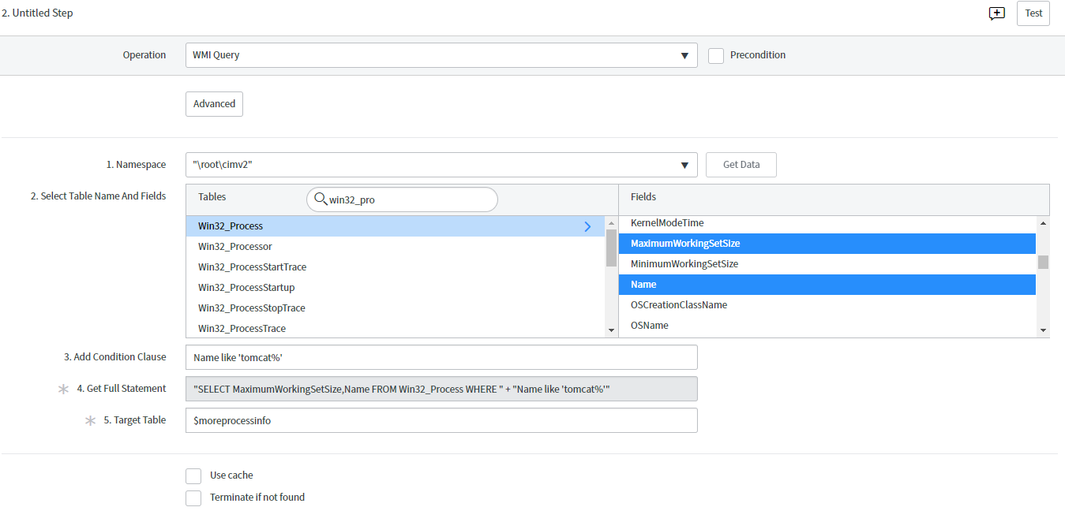

WMI Method Invocation:

As part of creating or modifying a discovery pattern, you can use the **WMI method invocation** operation to execute a method selected from a table returned by a WMI query.

| **Field** | **Description** |
| --- | --- |
| **Enter Source Table** | Specify the source table name. The source table must be the result of the WMI Query operation you perform before this step.  You can enter a value from the specific field in a table as described in [Enter values and variables in patterns](https://docs.servicenow.com/bundle/london-it-operations-management/page/product/service-mapping/reference/r_UsefulShortcutsPatDef.html). |
| **Enter WMI Method** | Select the desired method:   * In the debug mode, click **Get methods** and select the method from the list. * Not in the debug mode, enter the name of the method as a string, for example, "RunDetails". |
| **Enter Target Table** | Specify the target table name. |
| **Enter Target Column** | Specify the name of the column to contain the results of the method invocation. |

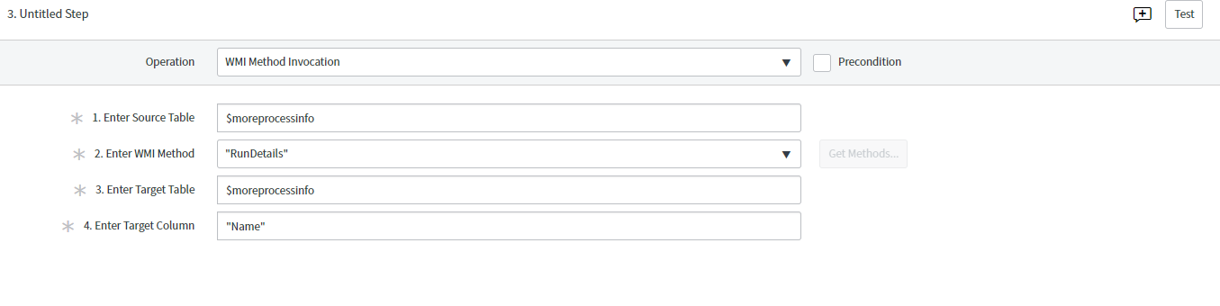

A pattern is a series of operations that tell Discovery which CIs to find on your network, what credentials to use, and what tables to populate in the CMDB.

## Differences between probes and patterns

|  |  |  |
| --- | --- | --- |
| Discovery Phases | 4 | 2 identification and exploration |
| Finding new CI | Probes and sensors | Use pattern designer |
| Feature support | Standard network and CI discovery | Cloud discovery  Configuration file tracking  CI deletion strategies |
| ECC Queue | Multiple | single |
| Performance | Longer time | faster |

## Horizontal discovery process flow with probes and sensors:

Horizontal discovery with patterns has four phases, just as horizontal discovery with probes does. However, for the last two phases, Discovery triggers operations from a pattern, rather than additional sets of probes.

## Scanning phase

1. Discovery first takes the Shazzam probe (and then [port probes](https://docs.servicenow.com/bundle/london-it-operations-management/page/product/discovery/reference/r_PortProbes.html#r_PortProbes)) and places it in a request in the External Communication Channel (ECC) queue.
2. The MID Server checks the ECC queue, retrieves the discovery request, and runs the probes against the host and discovers open ports.
3. The port probes scan common ports using several protocols, such as WMI, HTTP, SSH, and SNMP.
4. If one or more ports respond, the Shazzam probe sends information about the port back to the ECC queue through the MID Server.
5. Discovery checks the ECC queue to find out which ports responded, which identifies the type of machine. For example, if Shazzam detects that the machine is listening on port 22, Discovery treats the machine as a UNIX or Linux machine.

## Classification phase

1. The Discovery application determines which classification probe to send to the newly discovered device by using information in the record of the port probe that successfully responded.
2. Discovery puts the classification probe into the ECC queue.
3. The MID Server checks the ECC queue, retrieves the discovery request, and runs the classification probe.
4. The classification probe retrieves additional information, such as which version of the operating system is running on a machine. This information determines the class of the CI that Discovery found. There is only one classification probe per discovered device.
5. The classification probe sends information back to the instance ECC queue through the MID Server.

## The Identification and Exploration phases

Patterns unify the Identification and Exploration phases of discovery.

1. Discovery determines which classifier to use based on the class of the CI and the criteria specified in all CI classifier records. The classifier specifies the [Horizontal Pattern probe](https://docs.servicenow.com/bundle/london-it-operations-management/page/product/discovery/reference/r-HorizontalPatternProbe.html#r-HorizontalPatternProbe), which in turn specifies which pattern to launch. The Horizontal pattern probe also contains a sensor which does the actual work of updating the CMDB.

**Note:** Patterns need applicative credentials to find applications running on host machines. Make sure you have applicative credentials configured along with the credentials required to access the host machine itself.

1. The operations in the pattern specify the actions that Discovery needs to take for both the identification and exploration phases. Discovery knows which [identification rules](https://docs.servicenow.com/bundle/london-servicenow-platform/page/product/configuration-management/concept/c_IdentificationRules.html) to use based on the CI type in the pattern, and Discovery makes inserts or updates to the CMDB based on these rules. Only the Horizontal Discovery Sensor is used. Other probes and sensors are not used.